Output screenshots

1. Create a multiple instance .

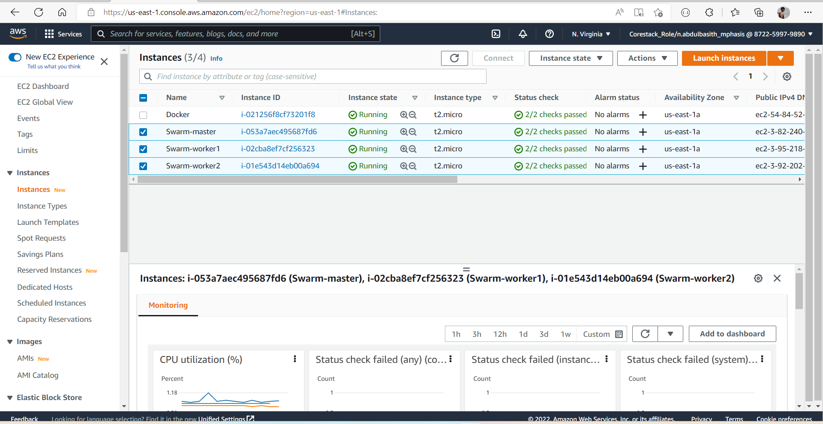

1. Edit the security group by edit the inbound rule and add all traffic type.

1. With the help of putty connect the instances.

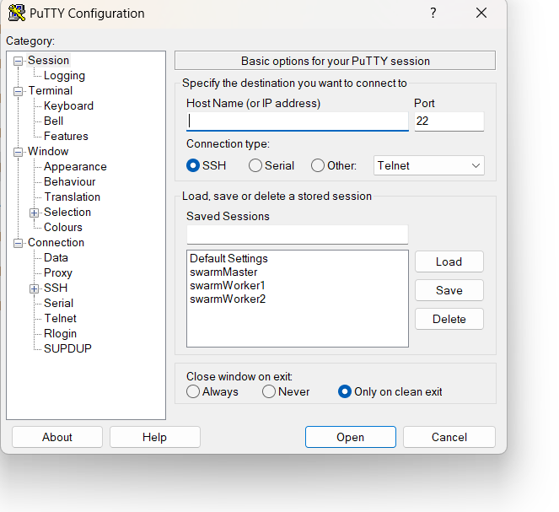

1. Write command on master node to connect other nodes (docker service create --name myapp1 --replicas 5 -p 80:80 abdulbasithn/mywebsiteimage

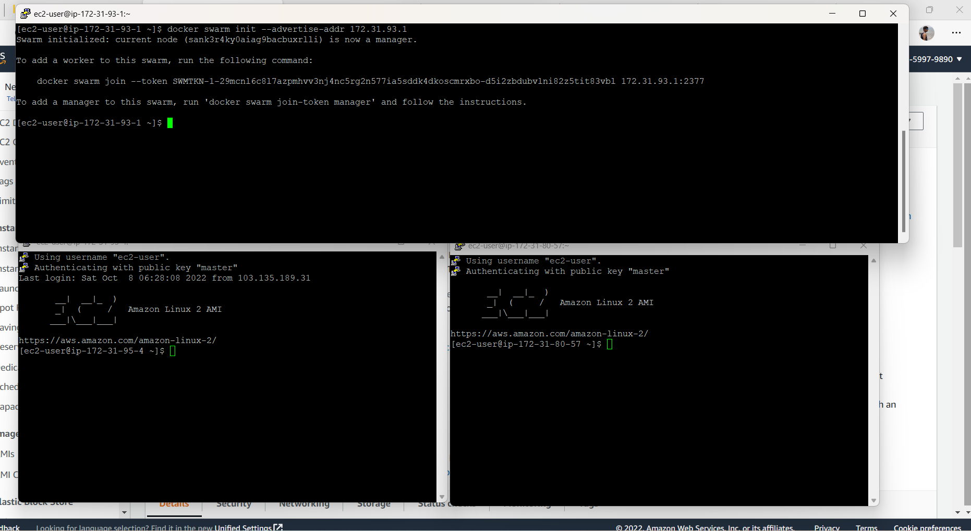

1. The master node will produce token , run the tokens in the other nodes to connect them.

1. Check the master node about the status of other node.

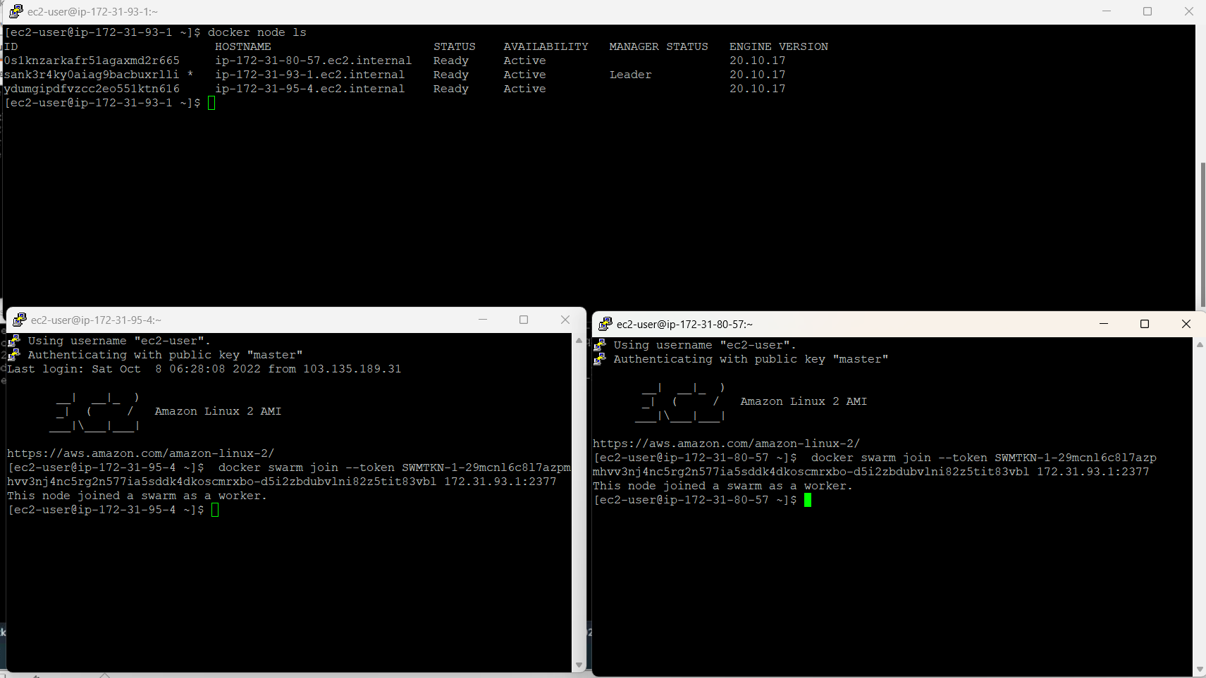

1. Create a service and add the image in container .

1. Check the service status about running.

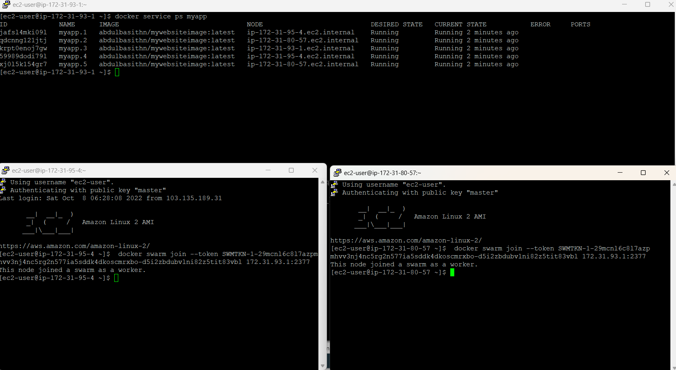

1. Run the ip address in the url.

